Falling Through the Cracks: Dealing with the Problem of the Unclassifieds in RELTRAD

**Abstract**

American religion can be characterized in countless ways. There are 350,000+ congregations and hundreds of millions of adherents, identifiers, and believers in the US. One of the primary tasks of science is to make sense of the chaos by proposing orderly taxonomies, combining and labeling like things so we can describe how much there is and whether and how they are changing. Because there is tremendous value in classification systems due to the research questions they enable, it is continually worth our while to examine their assumptions, fit, and coverage. One popular scheme for classifying “religious traditions” as laid out in the Steensland et al. (2000) appendix simply drops some respondents who are hard to classify. However, the proportion “Unclassified” has been growing from 2% in 1970 to 6.5% in 2018. In this paper, we document the problem and pose several solutions.

**Introduction**

It’s fair to say that most social scientists studying American religion are familiar with RELTRAD – a scheme for classifying religious identifiers that has been widely adopted by researchers from a variety of disciplines. It offers a shortcut for those who are only casually interested in American religion but it provides a framework of identification that has been used hundreds of times before without incident from reviewers. This choice becomes even more pragmatic when considering that there are sets of computer syntax already available online for omnibus survey data from the General Social Survey and American National Election Studies that generate the seven categories of RELTRAD in just a few minutes.

However, we would hazard a guess that most people who have employed the RELTRAD scheme have not looked under the hood of the computer code to see exactly how the seven categories were created to see some of the compromises that must be made into order to get the desired output. One of those compromises used to be a minor concern, but has become a significant flaw in the RELTRAD scheme – the application of an attendance filter for non-denominational Protestants, which is not applied to any other group. We argue that this has become more problematic and less theoretically viable over time as the share of Americans who identify as non-denominational has skyrocketed in the last two decades, leaving a larger and larger share of Americans left out entirely from RELTRAD and from the sample for analysis.

**A Brief Overview of Religious Classification**

When social scientists began to consider the role of religion in American life using survey data, it quickly became apparent that a framework needed to be developed to sort survey respondents into different categories. The earliest example is Samuel Stouffer sorting Protestants into Northern and Southern varieties (Stouffer 1955). From there, other approaches were proposed such as Tom Smith’s FUND classification, which gave every respondent one of the three labels: funadmentalist – moderate – liberal (Smith 1990). Smith’s work was considered to be overly reductive by some (e.g., Green et al, 1996), and never achieved widespread adoption.

However, a system of classifying religion was published just a few years later called RELTRAD (Steensland et al. 2000), which built on the earlier classification work by Green et al. (1996) and was quickly adopted by social scientists. RELTRAD has maintained its position as the most widely accepted taxonomy over the last two decades (Burge and Lewis 2018). While it has many detractors (e.g., Leege 1996; Djupe and Gilbert 2009; Sherkat 2014), its utility lies in its ability to not be overly reductive, while also not being so complex as to be incomprehensible. It does this by creating seven categories of religious identity: evangelical Protestant, mainline Protestant, black Protestant, Catholic, Jewish, other faith, and no religion.

However, that’s not to say that RELTRAD has not seen a fair share of criticism in recent years. For instance, Shelton (2018) poignantly asked: “Is RELTRAD Still the Gold Standard?” He notes a number of limitations with using this approach. Chief among them is a high likelihood of misclassifying evangelical and mainline Protestants (see also Blinded). Another concern is that RELTRAD is a small-sample scheme – it places those of other, small faiths into a singular category, for instance combining Jehovah’s Witnesses with Buddhists, which robs it of any real theoretical or empirical utility. Shifting to massive modern samples, for instance in the Cooperative Congressional Election Study, obviates the need for an “other” bucket. A final shortcoming that Shelton notes is the existence of a black Protestant category. Making this measurement decision indicates that black Protestants are somehow different than their non-black evangelical or mainline counterparts, but also insinuates that they are a somewhat monolithic bloc, an assertion that is obviously problematic (Shelton 2018). Of course, assuming that any of these categories are monolithic would be a mistake.

The original authors of RELTRAD have noted that the scheme has its limitations and likely needs to be modified in light of changes to American religion (Woodberry et al. 2012; Steensland et al. 2018). Other approaches to tweak RELTRAD to meet these shifts have been proposed, and many of them are much more limited in scope than the original typology (Lehman and Sherkat 2018; Smith et al, 2018; Burge and Lewis 2018). As part of a symposium regarding the difficulty of measuring American religion, Hackett et al. (2018) made an illuminating suggestion: “Choose the Method for Aggregating Religious Identity that is Most Appropriate for Your Research.” Obviously, this is good and sound advice, but we believe it's fair to say that RELTRAD is still going to be used by many scholars of American religion because of its ubiquity and ease of use.

**The Problem of the Unclassifieds**

In the spirit of being transparent about some of the shortcomings of RELTRAD, we would like to point out something that has been overlooked by those who use this approach in their research – it excludes a significant portion of the American population and that share has only grown in recent years. The issue comes when Steensland et al. confront the problem of non-denominational Protestants or those who claim no denomination at all. The operative question is whether these respondents are actually attending non-denominational churches or whether they selected this category as a socially-acceptable way of avoiding claiming no religion at all – akin to choosing the middle option in survey items.

To get around this thorny issue, the authors propose that non-denominational Protestants be cleaved based on attendance. To be more specific, the authors sort non-denom/nodenom respondents into the evangelical category “if they attend ‘about once a month or more’” (297). Where do infrequent attenders end up? “Respondents in the nondenom/no-denom category who attend church less than once a month are *omitted from our analysis*” (emphasis ours). This group of respondents don’t end up in the evangelical or mainline category. Nor are they lumped in with those of other faith or no faith at all. They are coded as “NA'' for RELTRAD and are left out of any analysis. For many software packages, those who are classified as NA don’t show up when working with the data – they simply disappear.

As can be quickly ascertained, this has become a problem, both from a data standpoint as well as theoretical one. One of the most commonly used frameworks for quantifying religiosity is called the three B’s – behavior, belief, and belonging. One of the reasons that RELTRAD is used so extensively is because it has a focus squarely on religious belonging. But just what belonging means is unclear. In most cases, the seven categories of the taxonomy are effectively religious identity measures – if they identify with a label, they are classified with that group. However, RELTRAD conflates religious belonging with religious behavior in the case of non-denominationals. Thus, some people are thrown into the unclassified not because they did not articulate a clear religious identity, but because they didn’t attend church frequently enough to be classified as evangelical. This attendance filter does not exist for United Methodists, Southern Baptists, or Catholics. In each of those cases, they are still classified with their identity group regardless of their level of attendance. So, even those who never attend religious services but have a brand-name religious identity “belong.”

We draw on the General Social Survey series to demonstrate the nature of the problem since the coding is consistent and this is where the scheme was hatched to begin with. Figure 1 lays bare the seriousness of the problem when combining religious behavior and religious belonging – lots of people are being left out. For much of the 1970’s through the late 1990’s this problem was small and seemed manageable – with between two and three percent of the sample being unclassified. However, in 1998 there was a dramatic increase in unclassified respondents – jumping to 4.5% and the number has only risen from there. In both the 2016 and 2018 waves of the GSS, at least 6.5% of all those in sample are placed in the NA category and are excluded from analysis. To put that in perspective, if unclassified was added to the RELTRAD category list, this group would be the fourth largest. There were more unclassifieds in 2018 than there were Jews, Black Protestants, and those of other faith traditions. Clearly, this is a problem that needs to be acknowledged and addressed.

**Figure 1 – Share Who are Unclassified in RELTRAD**

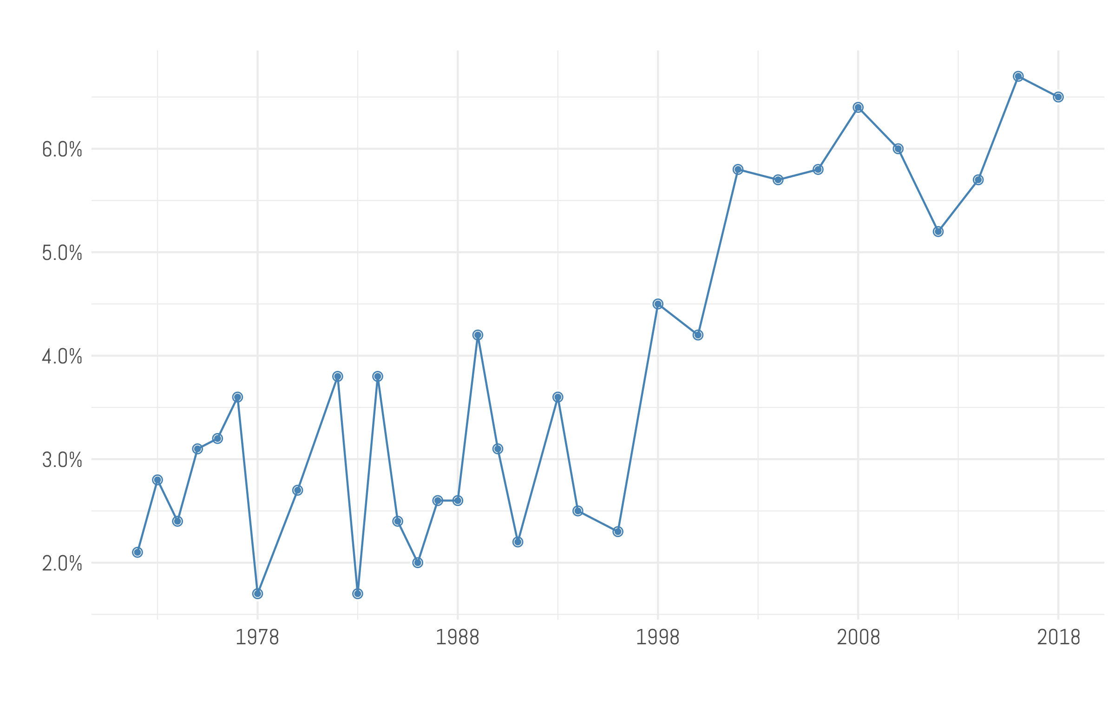

Source: GSS, 1972-2018

The primary factor that is driving this tremendous leap in unclassified individuals is that non-denominational Protestant Christianity has grown rapidly over the last three decades. In 1972, just 3.4% of all Protestants chose a non-denominational identity, but by 2018 had jumped nearly sevenfold to 22.9% of all Protestants in 2018. Most of that growth has happened since the mid-1990s. As denominations like the Southern Baptist Convention and the United Methodist Church have both seen declines in membership, non-denominationals have seen explosive growth.

Figure 2 makes it clear that solving the problem of the unclassified in the GSS has to come to terms with what to do with those who say that they are non-denominational. In almost every year of the GSS, dating back to 1972, three quarters of those who don’t get sorted into a RELTRAD category in the GSS attended a non-denominational church. If researchers could agree on a way to handle this issue of non-denominationals, the share of unclassifieds would drop to a much more manageable 1.5-2%.

**Figure 2 – Most of the Unclassifieds are Non-Denominational**

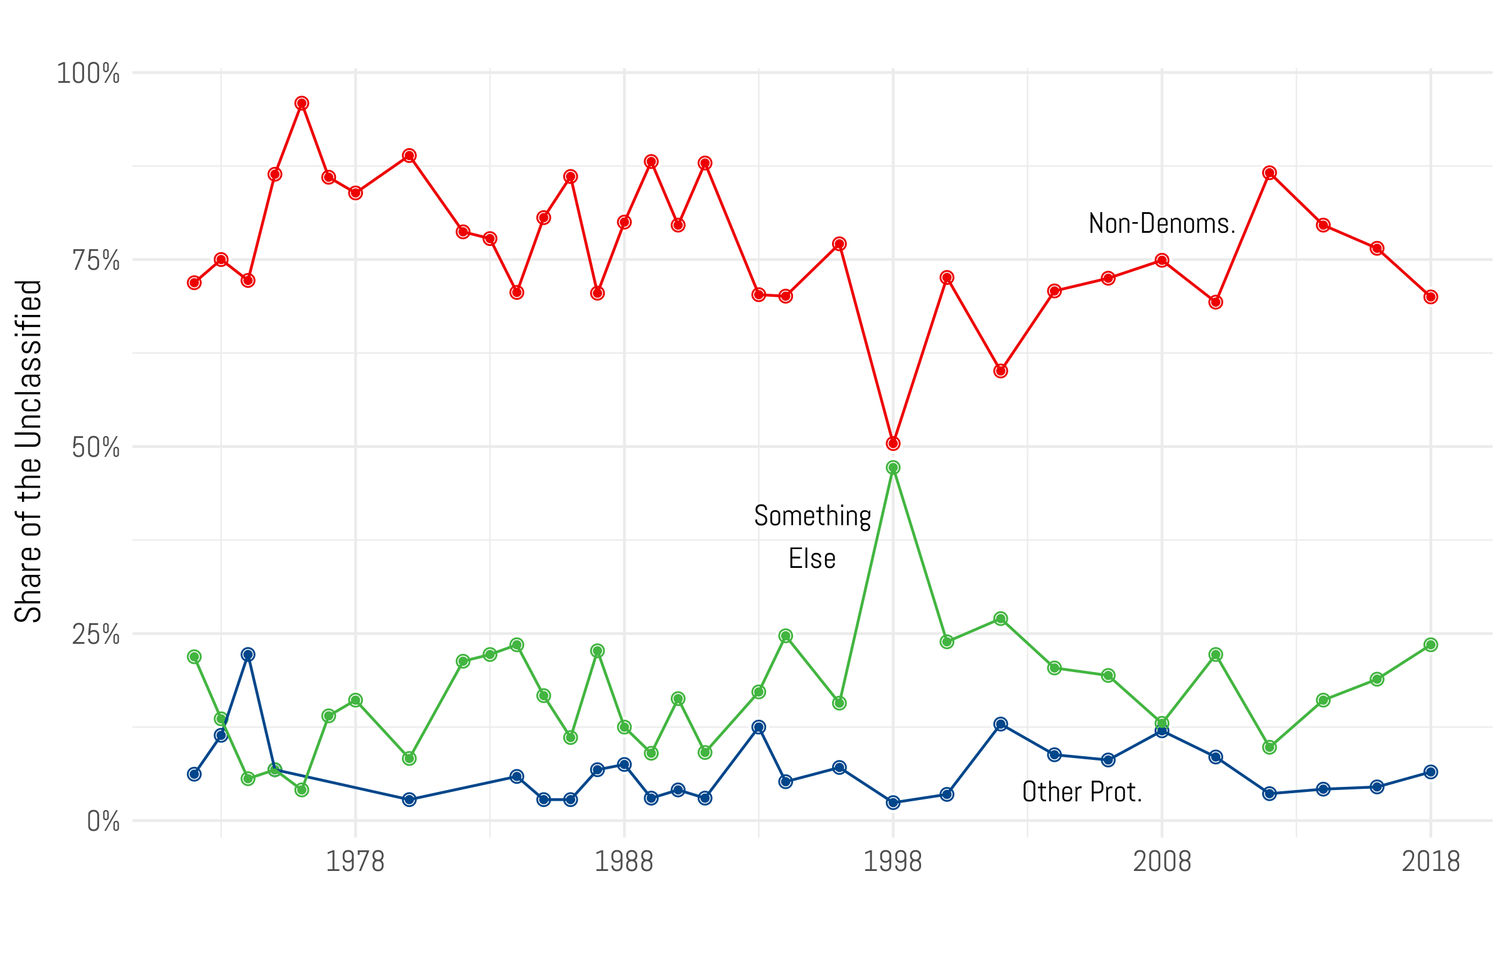

Source: GSS, 1972-2018

So, who are the Unclassifieds? Racially, they are predominantly white (69% in 2018, which is not dissimilar from the overall sample – 72.1% in 2018), however African-Americans are overrepresented among this group at 24% of unclassifieds (it’s 16.4% of the entire sample in 2018). In terms of basic religious identification, 52% identify as “born again or evangelical” while 48 percent do not. Though they do not attend church at high levels, other elements of the survey appear to give us considerable information with which to classify them, a decision Woodberry et al. (2012: 68-69) support: “Ideally, coding schemes should attempt to assign these ambiguous responses based on doctrinal markers and/or religious movement identifications as well as other religious beliefs and practices.” However, there are other possibilities we will explore below.

**How Do Unclassifieds Compare?**

Before moving on to the task of categorizing these unclassified respondents to the GSS, it is instructive to get a sense of where they fit compared to other large Protestant traditions. The most likely categories to sort the majority of the unclassifieds are either the evangelical or mainline categories. Thus, comparing non-denominationals to these groups is instructive. There is no clearer standard bearer of evangelical Protestants than the Southern Baptist Convention. It is the largest Protestant denomination in the United States (Pipes 2016), although its share of Americans has been a gradual decline over the last ten years (Shellnut 2019). Its mix of conservative theology and Republican politics makes it an ideal example of how researchers conceptualize the evangelical identity. If one is looking for a good reference case for mainline Protestants, the United Methodist Church is the clear choice. It is the second largest Protestant denomination in the United States (Robertson and Dias 2020). While their politics still lean slightly toward the Republican Party, they have embraced a more moderate theology that welcomes female pastors, although they in are the process of a denominational division over the issue of same-sex marriage (Anderson 2020).

The key comparison is the distribution of church attendance among Southern Baptists, United Methodists, and non-denominational Protestants. Recall that in the RELTRAD framework, a United Methodist is sorted into the mainline category, while all non-black Southern Baptists are considered to be evangelicals regardless of attendance level. For non-denominationals to be classified at all, they must attend services at least once a month or more. This split is indicated by the shaded box in Figure 3.

**Figure 3 – Attendance Distribution of Religious Traditions**

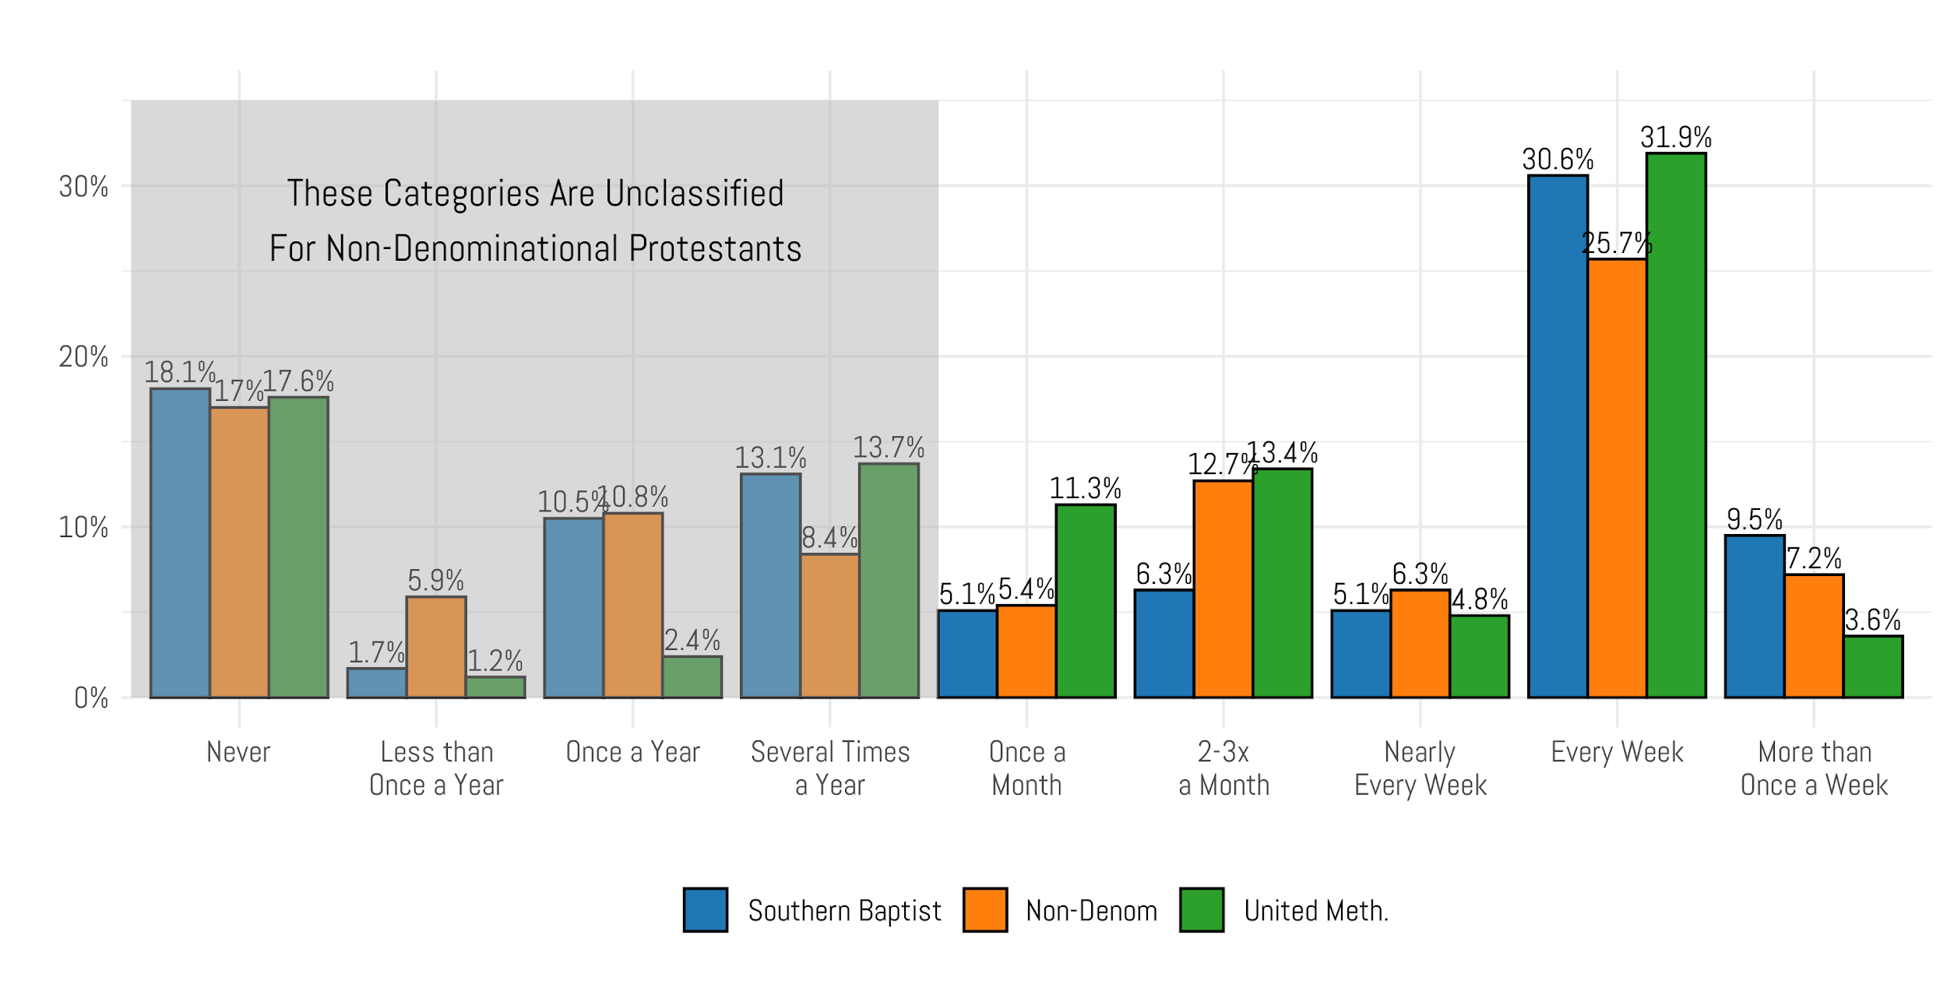

Source: GSS, 1972-2018

The portion of each of the three groups that falls into the shaded box is very similar. 43.4% of Southern Baptists attend church several times a year or less. It’s lower for United Methodists at 34.9%. The share of non-denominationals who attend less than twelve times a year is 42.1%. From this angle, it would appear that evangelicals are just as likely to be low attenders as non-denominationals, yet RELTRAD excludes over four in ten non-denominationals from any religious classification. It keeps the full share of Southern Baptists, despite the fact that their attendance is very similar in frequency to non-denominationals.

Generally, there are not large differences in attendance among the three Protestant denominations. For instance, there is no statistical difference in the share of each group that says that they never attend church services. At the top end of the scale, it does appear that non-denominationals are slightly less likely to attend church at least once a week. However, when the top two categories are combined the disparity does narrow somewhat. While 40.5% of Southern Baptists attend weekly, it’s 35.6% for United Methodists, and 32.9% for non-denominationals.

**Are Non-Denominational Attenders Similar to Religious Traditions?**

It is imperative to re-examine the logic of dividing non-denominational Protestants into evangelicals for those who attend at least once a month and marking unclassified those who attend less than that. Steensland et al (2000) write that, “(non-denom/nodenom) respondents who attend church frequently are similar in attitudes and behavior to evangelical Protestants” (298). Recall that RELTRAD was first published nearly two decades ago, when non-denominational identifiers were 5.7% of the population. By 2018, they have doubled in size to 11.3 percent – which could mean an overall shift in the attitudes and behaviors of this group. Moreover, recent analyses have suggested that involvement in non-denominational Protestantism does not have the same effects on political behavior that the literature has long found for denominational religion (Blinded).

To test that, we limited the sample to GSS respondents who took the survey between 2010 and 2018. Then, we divided United Methodist, Southern Baptist, and non-denominational respondents based on their attendance level as prescribed by the RELTRAD authors. Then we calculated the mean for a number of descriptive variables that gauged religious belief: the share who were biblical literalists, those who claimed a born-again identity, and the portion who said that they believed that God existed without any doubt. We also included two measures of political identities: the share who identified with the Republican party, and those who described their political ideology as conservative. The point estimates are visualized below in Figure 4, and the horizontal lines denote 84% confidence intervals.[1]

On measures of religious belief and identity, it is clear that high-attending non-denominational Protestants look very similar to Southern Baptists. In fact there is no statistical difference between the two groups on measures that tap into belief in God, and the share who identify as born-again or evangelical. On both counts, United Methodists are clearly distinct. United Methodists also lag farther behind on biblical literalism. Just about 4 in 10 members of the UMC believe that the Bible is literally true, compared to 61% of non-denominational Protestants and 71% of Southern Baptists. Here, there is some separation between the prototypical evangelicals and non-denominationals. On matters of politics, the differences are much smaller. For instance, there is no statistical difference in the share of each group that identifies as a Republican, with estimates for each between 48 and 53 percent. United Methodists are slightly less likely to identify as politically conservative, but there is no difference in the point estimates for non-denominationals and Southern Baptists. Thus, we can say that the logic that motivated the creators of RELTRAD to place high-attending non-denominationals in the evangelical camp still finds empirical support in more recent data.

However, where do low-attending non-denominationals fit compared to United Methodists and Southern Baptists? The picture here is not nearly as clear. While the graph above indicates that on most measures high attending non-denominationals look like high-attending Southern Baptists, that’s not the case among those who attend less than once a month. In fact, on the three measures of religious belief: doubts about God, having a born-again identity, and biblical literalism, non-denominationals are clearly less conservative than Southern Baptists, but are not as liberal as United Methodists. On doubts about God and biblical literalism, they do seem to be slightly closer to Methodists than evangelicals.

Figure 4 – Comparing Non-Denominationals with Religious Traditions, by Attendance Levels

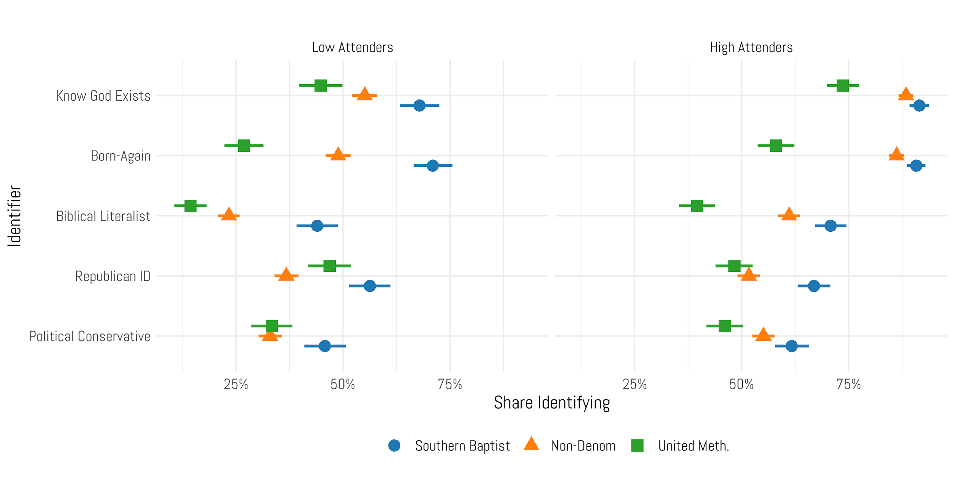

Source: GSS, 1972-2018

On measures of political ideology and partisanship, the picture becomes even more clouded. For instance, when calculating the share of each of the three groups that identify as politically conservative, there is no statistical difference between the UMC and non-denominational samples. In comparison, low attending Southern Baptists are slightly more likely to identify as politically conservative, although the total difference is not substantively large (just about 9%). When the measurement shifts to political partisanship, non-denominationals become the outlier. One of the reasons is that while just 33.4% of United Methodists identify as politically conservative, 46.9% identify as Republicans. This shift is much more subtle for Southern Baptists (5.4%) and non-denominationals (3.8%). This serves to make non-denominationals stand out from the other two groups.

Among high attenders, it’s clear that non-denominationals tend to have religious and political views much the same way as evangelical Southern Baptists, but that’s not the case for those who attend less frequently. On measures of religiosity, it’s fair to say that non-denominationals are neither mainline nor evangelical in their theological outlook. In reality, they stand somewhere between these two groups. On measures of partisanship, there is some substantive difference between non-denominationals and Southern Baptists, but it’s also fair to say that the political views of non-denominational Christians don’t look like mainline Protestants, either.

There’s a danger at this juncture to make classification decisions to emphasize fit – this is also known as selecting on the dependent variable. We should try to avoid that as well as adopt rules that can apply universally. Because non-denominationals do not have collective organizational histories and statements of commitments, they subvert the usual decisions rules about how to treat them as a group. In the end, it is this fact that we key on, as well as nascent empirical evidence, to advocate for a particular option for their treatment.

**Ways Forward**

From the prior analysis, there are two central takeaways. The first is that the attendance filter used to bifurcate the non-denom/nodenom sample is no longer tenable. When RELTRAD was first proposed, just 2% of individuals fell into the unclassified category – however, that number has risen to over 6% now which makes it clear that retaining the attendance filter is tremendously expensive, if nothing else. There needs to be a carefully considered revision to RELTRAD that will sort as many people as possible into identifiable categories of American religion.

However, what to do to fix this problem is not obvious. High attending non-denominationals do look very much like evangelical Christians. The problem arises when considering non-denominationals who attend with less regularity. They don’t look like evangelicals in terms of political or religious viewpoints but they are also somewhat less liberal on matters of religiosity and ideology than the mainline United Methodists.

Therefore, we will offer up four possibilities to resolve this classification problem. Each has a number of positive and negative implications for measuring American religion, and clearly none is perfect.

**Option 1 – Apply the attendance filter universally**

One possibility is to simply apply the attendance filter universally so that all nominal affiliates are shuffled off from their religious coil. This would place all high-attending non-denominationals into the evangelical category. We would lose the widespread sense of religious identity that many Americans still have, but we would have a much clearer picture of just how weak religious organizational attachments actually are.

Figure 5 – How Using a Consistent Attendance Filter Changes American Religion

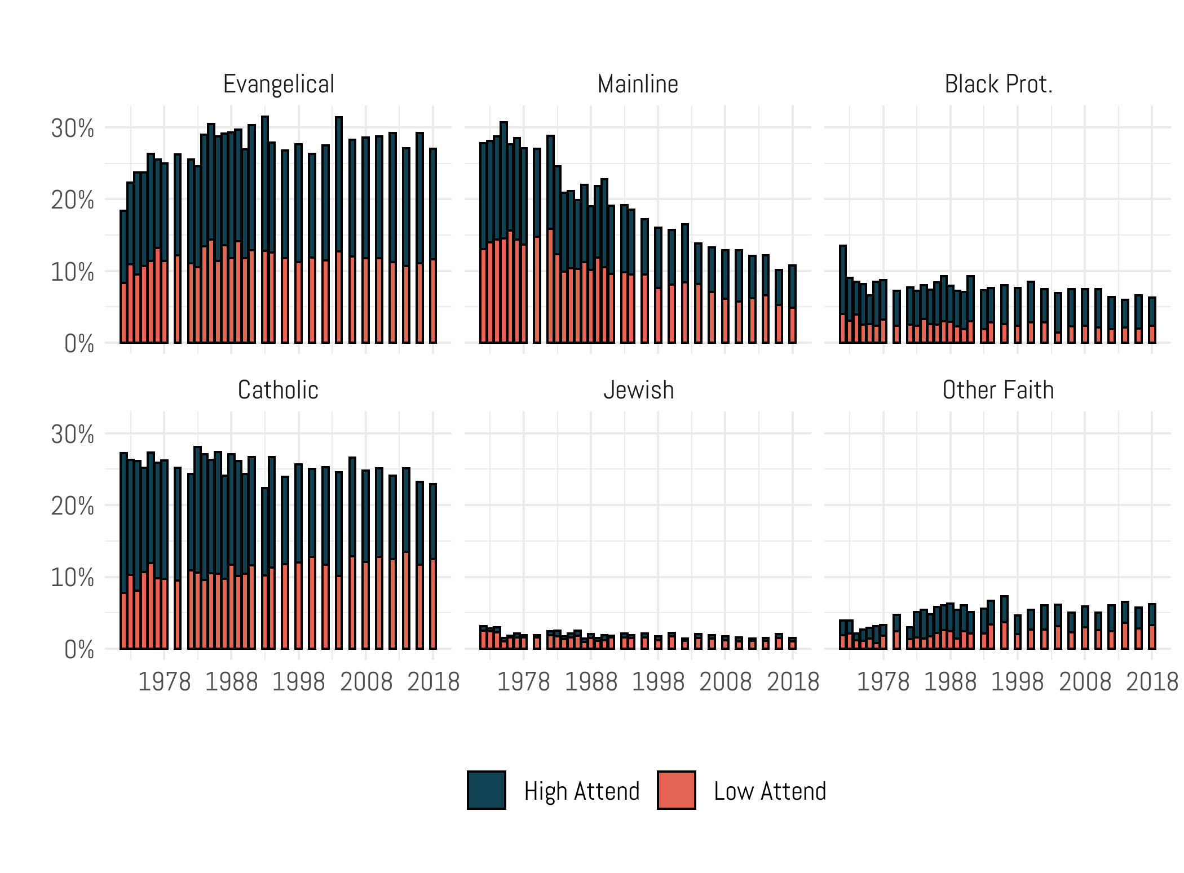

Source: GSS, 1972-2018

This approach would make the size of evangelicals larger – now at 27 percent in 2018, which is an increase of nearly five percentage points from the current RELTRAD calculation. However, the split between high attending and low attending evangelicals is noteworthy. 15.4% of all Americans are high attending evangelicals, compared to 11.6% who attend less than one in a month – 43 percent of evangelicals are nominal. The other traditions do not grow larger in overall size by making this shift, but it does elucidate how few of them are attending on a regular basis. For instance, six in ten mainline Protestants fall in the high church attendance category, while four in ten are low attenders. For Catholics, the low attenders outpaced the higher attenders in 2018 (12.5% vs 10.4%). In sum, nearly three in ten Americans are marginally attached Christians who could be dropped from the analysis if treated the same way as non-denominationals.

However, we must be realistic. Researchers cannot simply cut 30 percent of the sample (by excluding the low attenders) and expect to be taken seriously. But seeing the size of the nominally religious is a useful exercise, in part because this population has been growing steadily since the 1990s. Researchers need to be prepared to grapple with the fact that fewer and fewer religious identifiers are meaningfully exposed to social dynamics within American congregations. Put another way, more and more Americans are becoming RINOs (religious in name only) every year, which is only a short leap to status as a none.

**Option 2 – Classify all non-denominationals as evangelicals**

Perhaps the most straightforward path forward is to simply remove the attendance filter and convert all Protestants who identify as non-denominational or without a denomination as evangelicals. This has the benefit of simplicity – these two groups are considered to be evangelicals no matter how often they attend. This creates a consistent framework for non-denominationals, making them akin to other evangelical denominations like Southern Baptists. But, this choice has obvious implications for the size of religious traditions that may not be warranted.

Figure 6 – Adding All Non-Denominationals to the Evangelical Category

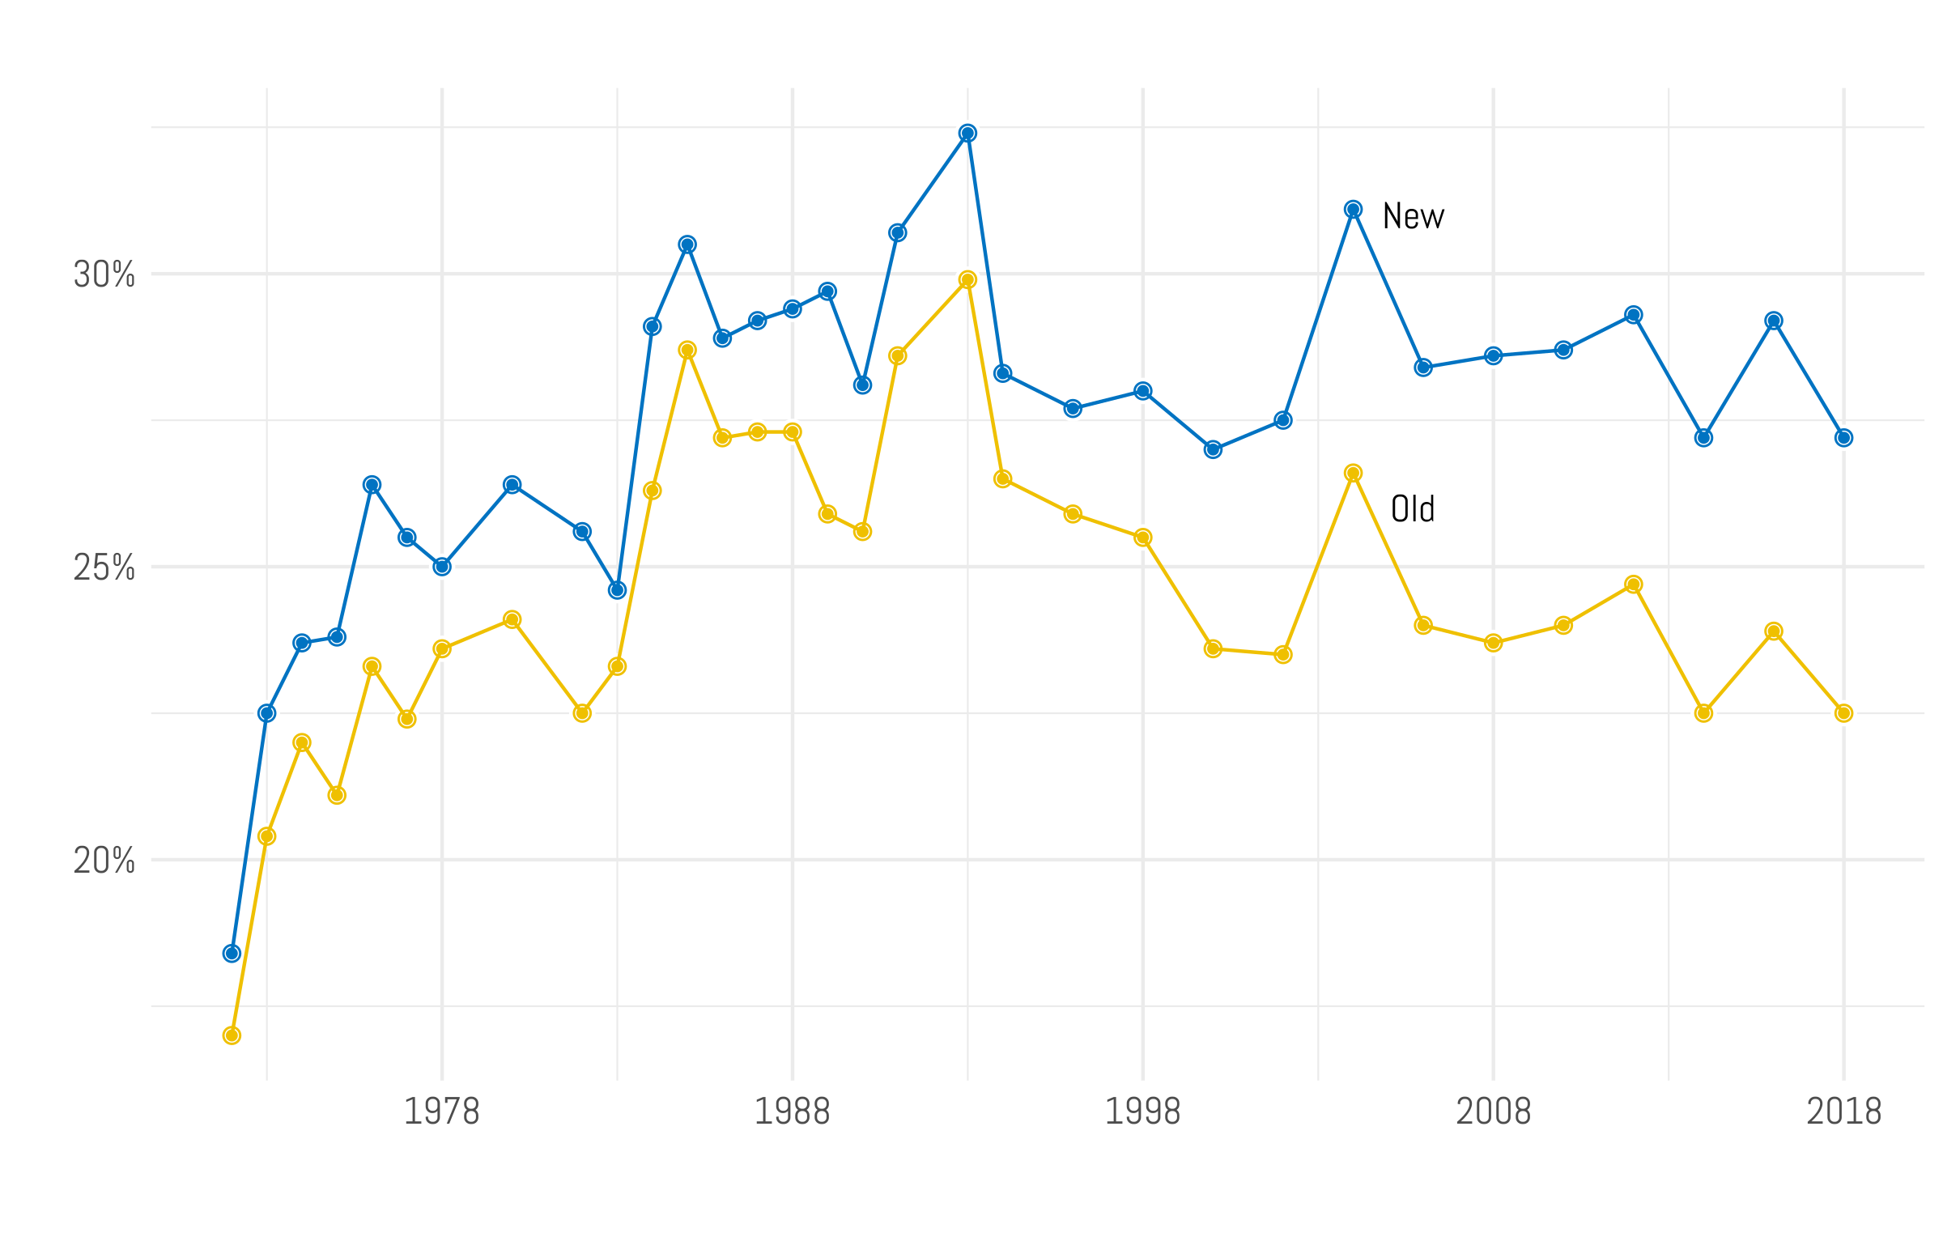

Source: GSS, 1972-2018

In the first two decades of the General Social Survey, this does not increase the size of the evangelical category substantially. For instance, in 1972 it increased the evangelical share from 17 to 18.4 percent. But, because the number of Americans who identify as non-denominational has increased significantly, that would translate to a much higher share of evangelicals in the last few years. In 2018, the prior version of RELTRAD classified 22.5% of Americans as evangelicals; this new approach places that figure much higher – at 27.2%. Using the framework proposed by Steensland et al. (2000), the share of Catholics, evangelicals, and the religiously unaffiliated are statistically the same in 2018. This new conception would push the share of evangelicals to be the largest religious tradition in the United States. This may be confusing for casual observers of American religion.

**Option 3 – Classify low-attending non-denominationals as mainline Protestants**

If we are operating under the assumption that the unclassifieds have to be sorted into an existing RELTRAD category, then a third option is to place some of them into the mainline Protestant group. As previously discussed, there are some instances in which non-denominationals who attend church less than once a month have more similar characteristics to United Methodists than they have in common with Southern Baptists. The end result of making this switch is visualized in Figure 7; recall that this will have no effect on any other RELTRAD group as low attending non-denominationals were not sorted into any other tradition before this.

Figure 7 – Adding Low Attending Non-Denoms to the Mainline Category

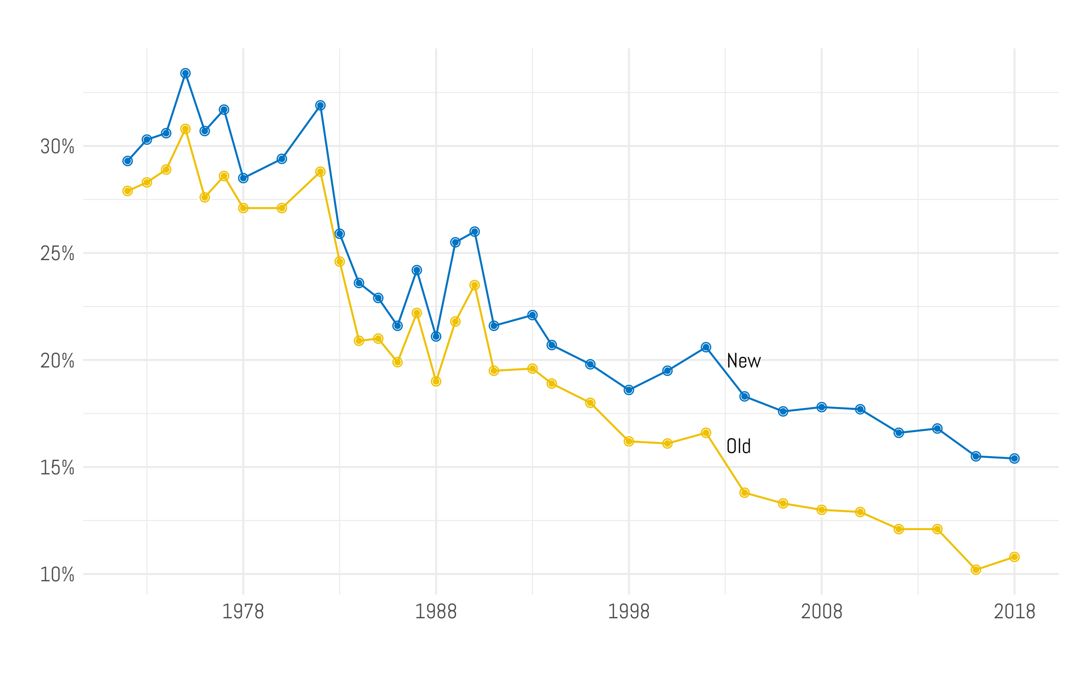

Source: GSS, 1972-2018

The result is a less bleak picture for the future of the mainline Protestant tradition. For instance, using the prior version of RELTRAD, mainline Protestants were just ten percent of the sample in 2016. If these unclassifieds were grouped together with mainliners, then the end result is that just over 15% of Americans were mainline in 2016. That would come as good news to those in the mainline tradition, but does it make sense from a theoretical perspective? It strikes us as awkward that non-denominationals who attended frequently were placed in one tradition, while those who attended less were put into another category. Put another way, mainline Protestants are not just less observant evangelicals. The original logic of RELTRAD was to specify the organizational location of the individual. People in the same sanctuary should not be differentiated in the classification scheme by their attendance levels. Though, as a practical matter, attendance levels surely correlate with knowing more aspects of the congregation. Moreover, mainline Protestantism is, canonically, a denominational enterprise. There is a sizable movement of “community churches” – about a quarter of non-denominational identifiers – who have more in common with mainline Protestants and consider themselves interdenominational. Otherwise, non-denominationalism is largely evangelical and is more consistent with the individualism of evangelicalism.

**Option 4 – Create an Entirely New RELTRAD Category**

The other viable option that remains may be the most radical – adding an entirely new category to RELTRAD for those who respond to the question about religious affiliation by claiming that they are non-denominational, have no denomination, identify as Protestant but don’t know which specific tradition, or those who claim just a Chrisitian identity. This growing category would be the fourth largest of any religious tradition. This has the benefit of removing the attendance filter for all religious traditions. It also makes clear that non-denominational Christians have an increasing presence and are potentially having an increasing influence and need to be understood as a separate category among American Protestantism. It therefore would be helpful to rename evangelicals as “denominational evangelicals” to make clear that non-denominationals have clearly shed the particularistic denominational identity.

This option loses steam if a nondenominational identity is a difference without a distinction. Indeed, there appears to be pressure on denominational churches to rebrand themselves as independent, primarily by changing their names. But even though non-denominationals appear to share many religious attributes with evangelicals, forthcoming work demonstrates a wide variety of dissimilarities in the effect of nondenominational church involvement on social ties, social orientations, and political involvement (blind for review). On this basis of these differences, we support the creation of a separate category.

Figure 8 – Creating a New Non-Denominational Category

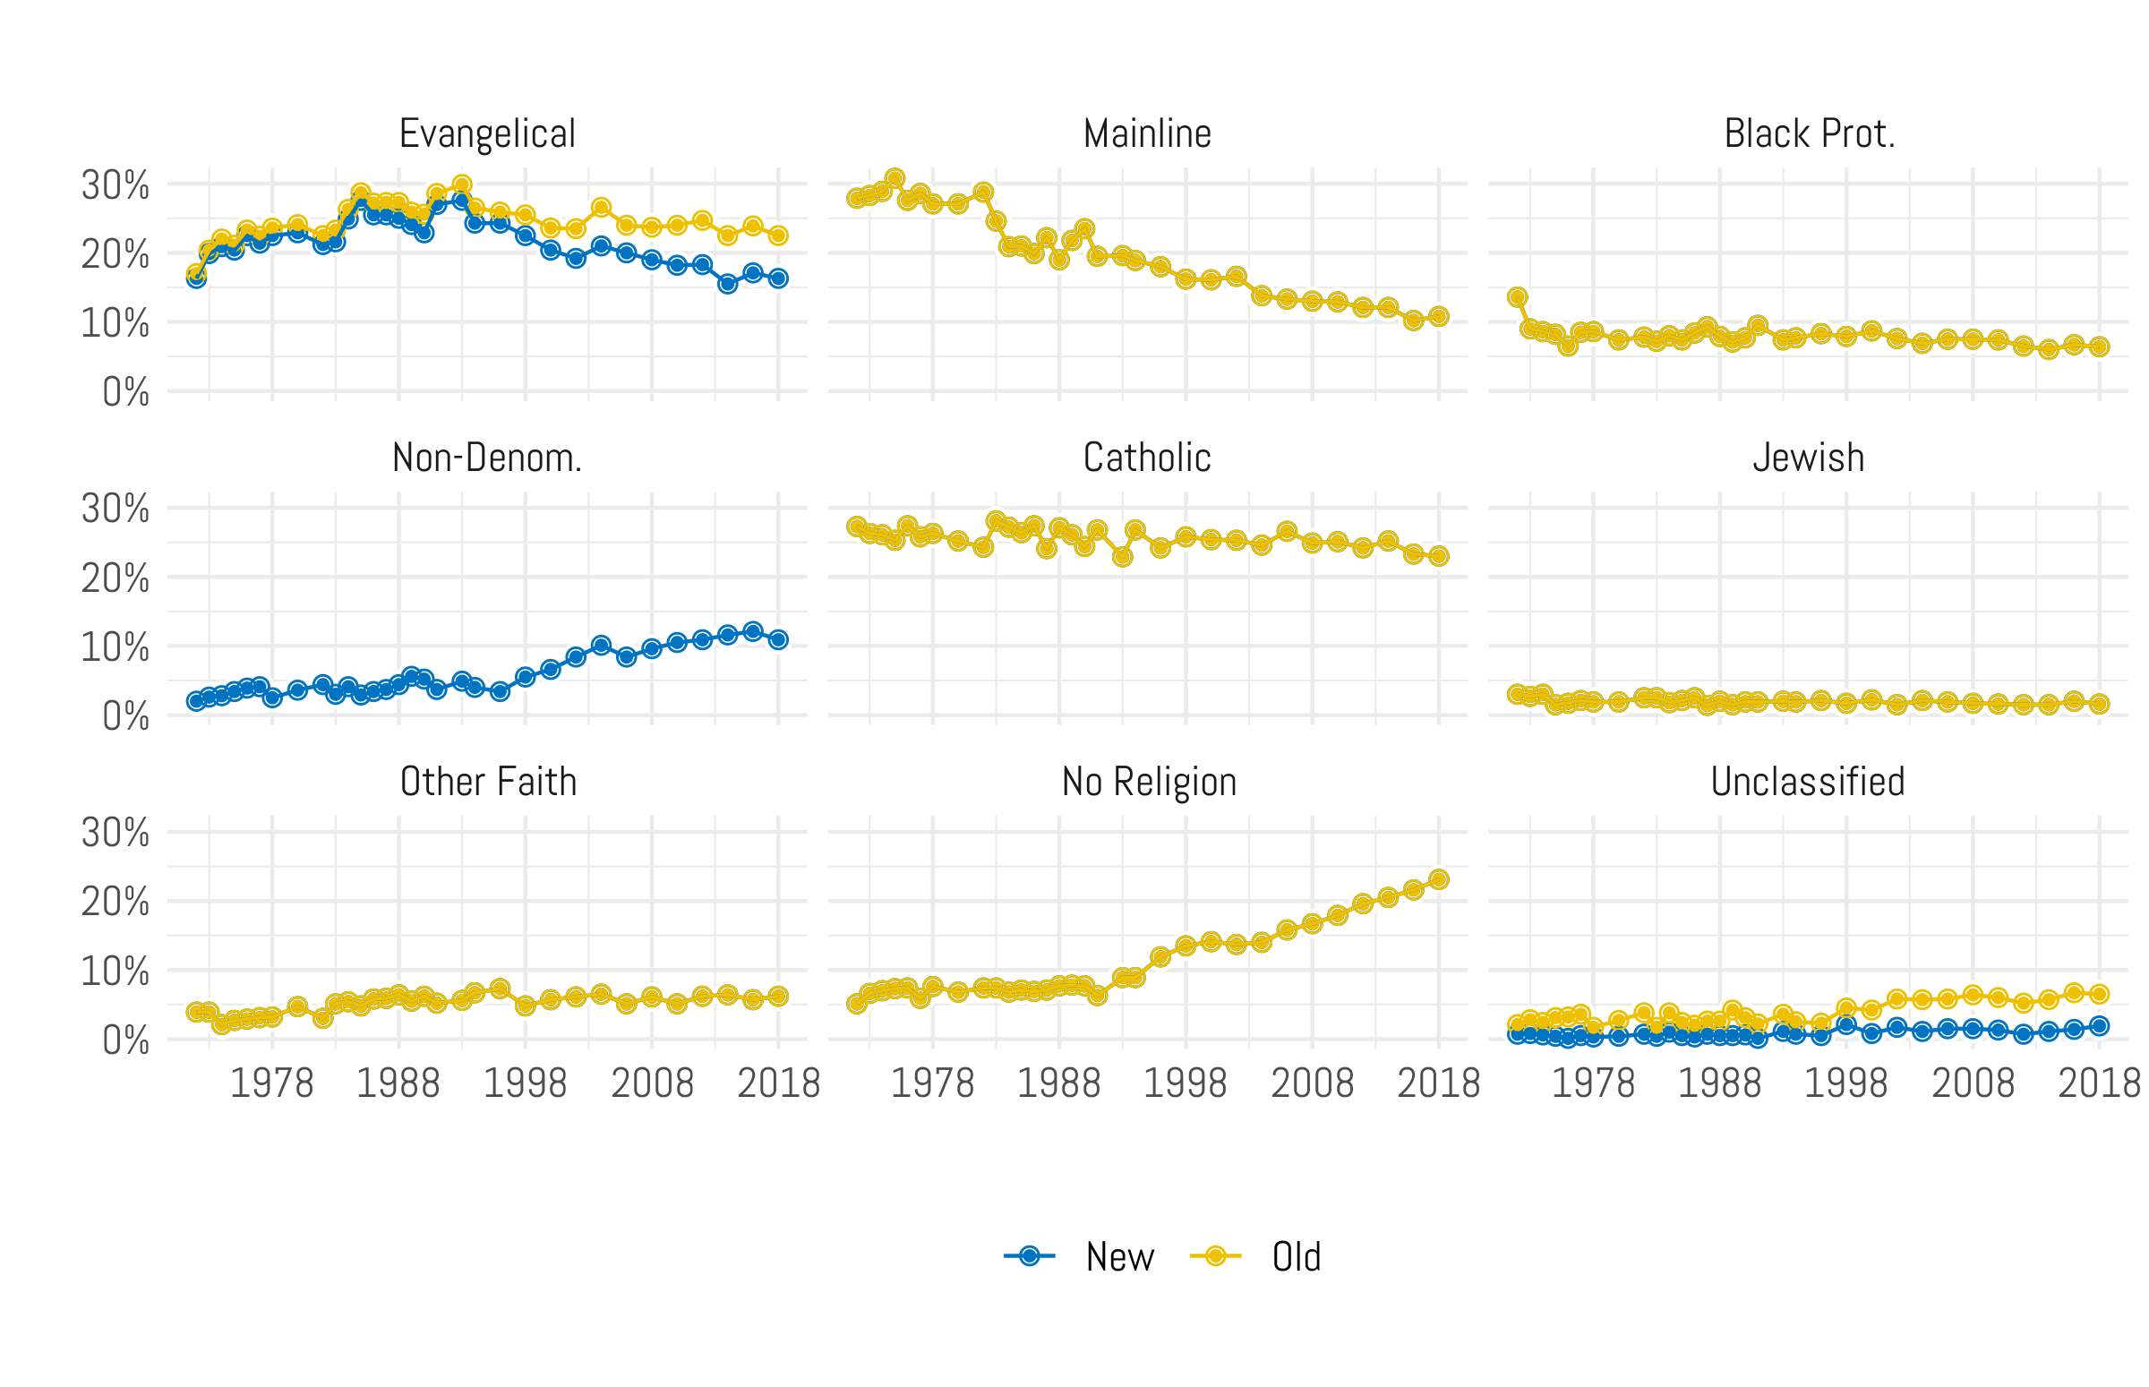

Source: GSS, 1972-2018

The implications of making this addition only shift two specific groups: evangelicals and those who are unclassified. Obviously, this framework will reduce the share of Americans who are evangelicals. Again, this does not make a large difference in the size of evangelicals until the late 1990’s. By 2000, the new framework classifies 20.4% of respondents into the evangelical camp vs. 23.6% using the prior version of RELTRAD. By 2018, this gap nearly doubles to 6.2% (16.3 vs. 22.5 percent).

The other implication, of course, is that the unclassifieds dramatically shrink. While they currently stand at 6.5% using the prior version of RELTRAD, under the new framework they are just 1.9% of the population – which is made up entirely of people who just don’t answer the religion questions. That is an ideal outcome.

A final upshot of moving to this additional category is that it clearly illustrates a crucial shift in American religion – away from denominational forms of Protestant Christianity and toward a faith that is less centrally organized. The public can understand that while some types of faith are holding steady (denominational evangelicals, black Protestants, Catholics), there are two other groups that are increasing in size – non-denominationals and those of no religious affiliation. We believe that both those stories are worth bringing front and center and that’s what this approach accomplishes.

**Implications of a New Category**

If RELTRAD is expanded by adding a new category for non-denominational Protestants, what implication does that have on modeling going forward? To test that we replicated a model found in the original analysis for RELTRAD that used church attendance as the dependent variable (Steensland et al. 2000, 302). This seemed like the ideal model to specify because it focuses on one of the sticking points about how RELTRAD is constructed – the conflation of religious identity and religious behavior. The prior model had controls for black, age, education, gender, the year of the GSS, income, and a dummy variable for those living in the South. In addition, we included our new RELTRAD model and set the reference category to the same one used by the authors – those without a religious affiliation. A simple linear regression was conducted with the outcome visualized as a coefficient plot in Figure 9 with robust standard errors and 95% confidence intervals. Additionally, the variables were scaled 0-1 so that interpretations of magnitude can be easily discerned. The interpretation of the model is straightforward – if the point estimate and confidence intervals don’t overlap with the vertical, dashed line on zero, the coefficient is significant. If it is to the right of zero, it predicts higher levels of attendance – lower levels are predicted to the left of zero.

Figure 9 – Model Estimates of Worship Attendance Using the Old and Newly Proposed RELTRAD Schemes

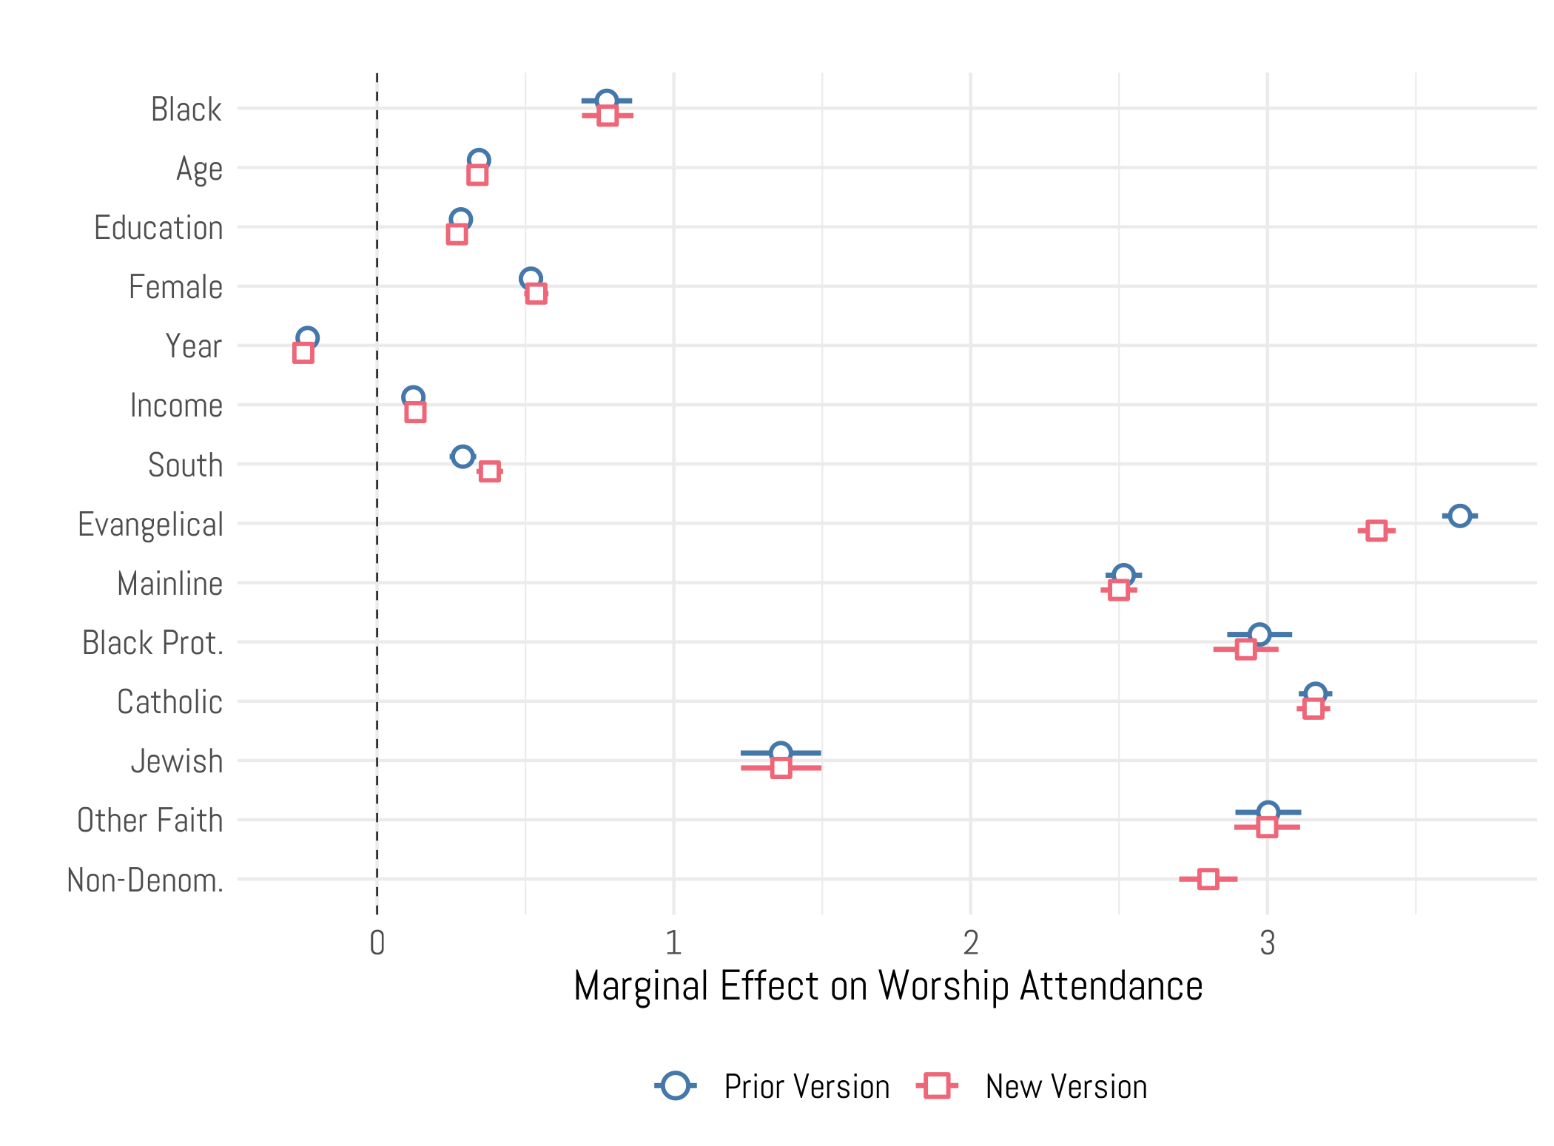

Source: GSS, 1972-2018

First note that in the case of the control variables there are no statistically significant differences between the models. In both cases, a black racial identity, age, education, being female, and having a higher income predict higher levels of attendance. The impact of a variable for the year of GSS is negative, meaning people in more recent waves of the GSS evince lower levels of worship attendance. The only variable that acts differently in the new model is a dummy variable for those living in the South. Using the newly proposed RELTRAD scheme, the impact of living in the South on worship attendance is slightly stronger.

Turning now to the categories for both the old and new versions of RELTRAD, we reach a similar conclusion as the control variables – in most cases the difference in the models is not statistically different. In fact that’s true for mainline and black Protestants, Catholics, Jews, and those of other faith traditions. The key difference, though, is between the impact of an evangelical affiliation on church attendance between the prior model and the proposed one. In the prior typology, there is a stronger positive relationship between being an evangelical and attending church services. In the new proposal, that impact is somewhat muted. Why is this the case? It’s because the prior version of RELTRAD had attendance baked into the category because non-denominational Protestants were sorted into the evangelical category based on an attendance filter. Once that filter is removed, the coefficient becomes smaller.

There are two takeaways from this model: first, it’s important to note that even in the new model there is still a strong link between evangelical identity and church attendance. In fact, it’s still the religious tradition with the highest average attendance. The other important finding is the coefficient for the non-denominational group. In the newly proposed version of RELTRAD, non-denominationals have a coefficient that is statistically no different than black Protestants and slightly higher than mainline Protestants. That would fall in line with the overall impressions generated from the analysis in Figure 4 – non-denominationals are more religiously devout than mainline Protestants, but not quite as much as denominational evangelicals.

**Discussion**

In recent years, a cottage industry has popped up among those who study religion to try and understand the implications that RELTRAD has had on the way that we think about the American religious landscape (see, e.g., *Jo*[*urnal for the Scientific Study of Religion*](https://onlinelibrary.wiley.com/journal/14685906), [Volume 57, Issue 4](https://onlinelibrary.wiley.com/toc/14685906/2018/57/4)). We fully recognize that RELTRAD is not going away any time soon. It gives researchers a simple and well organized framework for placing respondents into easy to remember and, more or less, theoretically coherent categories. The creation and implementation of RELTRAD has done a great service to those of us who study religion. So, instead advocating for a total reconfiguration of the typology, we instead suggest a modification based on the changes in American religion.

Non-denominational Protestant Christianity was just 8% of all Protestant Christians when the original version of RELTRAD was published. Obviously the authors of the original scheme could not have guessed that in just two decades the share of non-denominational Protestants would nearly triple in size. Thus, our suggestion is an amendment to RELTRAD – add a non-denominational category that will solve two significant problems. First, it will reduce the size of the unclassified category from over six percent to under two percent. It has become impossible to ignore the fact that such a large portion of the population is excluded from the analysis. The second problem that this new proposal overcomes is that it does not conflate religious identity with religious behavior. Instead, the entire scheme is based on religious traditions and/or denominations. The end result is what we believe to be more accurate modeling, especially when those models are using worship attendance as either a dependent or independent variable.

Any classification scheme of American religion is a product of the era that it was created in. As RELTRAD achieves twenty years of widespread use in our subfield, we feel that this amendment will continue to make it viable for many years in the future.

**References**

Anderson, Meg. 2020. United Methodist Church Announces Proposal to Split Over Gay Marriage. National Public Radio. <https://www.npr.org/2020/01/04/793614135/united-methodist-church-announces-proposal-to-split-over-gay-marriage>

Burge, Ryan P. and Paul Djupe. 2018. A New Religious Group is Skyrocketing: The Unclassifieds. *Religion in Public*. <https://religioninpublic.blog/2019/07/24/new-religious-group-is-skyrocketing-the-unclassifieds/>

Burge, Ryan P., and Andrew R. Lewis. 2018. “Measuring Evangelicals: Practical Considerations for Social Scientists.” Politics and Religion: 1–15.

Djupe, Paul A., and Christopher P. Gilbert. 2009. *The Political Influence of Churches.* New York: Cambridge University Press.

Goldstein H., and Healy M.J.R. (1995), The graphical presentation of a collection of means. *Journal of the Royal Statistical Society A,* 158: 175-177.

Green, J.C. 1996. Religion and the Culture Wars: Dispatches from the Front. Rowman & Littlefield Publishers.

Knol, M. J., Pestman, W. R., and Grobbee, D. E. (2011), The (mis)use of overlap of confidence intervals to assess effect modification. *European Journal of Epidemiology,* 26: 253-254.

Leege, David C. 1996. “Religiosity Measures in the National Election Studies: A Guide to Their Use, Part 2.” Votes and Opinions Newsletter of the APSA organized section on Elections, Public Opinion, and Voting Behavior 2(July/August): 6–9, 33–6.

Lehman, Derek, and Darren E Sherkat. 2018. “Measuring Religious Identification in the United States.” Journal for the Scientific Study of Religion 57(4): 779–94.

MacGregor-Fors, I., and Payton, M.E. (2013), Contrasting Diversity Values: Statistical Inferences Based on Overlapping Confidence Intervals. *PLOS-One*, 8(2): e56794.

Payton, M.E., Greenstone, M.H., and Schenker, N. (2003), Overlapping confidence intervals or standard error intervals: What do they mean in terms of statistical significance? *Journal of Insect Science*, 3:34-39.

Pipes, Carol. 2016. “ACP: More churches reported; baptisms decline.” *Baptist Press*. <http://www.bpnews.net/46989/acp-more-churches-reported-baptism-worship-numbers-decline>

Roberston, Campbell and Elizabeth Dias. 2020. “United Methodist Church Announces Plan to Split Over Same-Sex Marriage.” *New York Times*. <https://www.nytimes.com/2020/01/03/us/methodist-split-gay-marriage.html>

Shelton, Jason E. 2018. “Is RELTRAD Still the Gold Standard?” Journal for the Scientific Study of Religion 57(4): 817–26.

Shellnut, Kate. 2019. “Southern Baptists Down to Lowest in 30 Years.” *Christianity Today*.

<https://www.christianitytoday.com/news/2019/may/southern-baptists-acp-membership-baptism-decline-2018.html>

Sherkat, D.E., 2014. *Changing faith: The dynamics and consequences of Americans’ shifting religious identities*. NYU Press.

Smith, Tom W. 1990. “Classifying Protestant Denominations.” Review of Religious Research 31(3): 225–45.

Smith, Gregory A., Elizabeth Podrebarac Sciupac, Claire Gecewicz, and Conrad Hackett. 2018. “Comparing the RELTRAD and Born-Again/Evangelical Self-Identification Approaches to Measuring American Protestantism.” Journal for the Scientific Study of Religion 57(4): 830–47.

Steensland, B., J.Z. Park, M.D. Regnerus, and L.D. Robinson. 2000. “Measure of American Religion: Toward Improving the State of the Art, The.” Social Forces 79: 291.

Steensland, Brian, Robert D. Woodberry, and Jerry Z. Park. 2018. “Structure, Placement, and the Quest for Unidimensional Purity in Typologies of American Denominations.” Journal for the Scientific Study of Religion 57(4): 800–806.

Stouffer, S.A. 1955. “Communism, Conformity, and Civil Liberties: A Cross-Section of the Nation Speaks Its Mind.” Garden City, NY: Doubleday, 1955.

Woodberry, Robert D. et al. 2012. “The Measure of American Religious Traditions: Theoretical and Measurement Considerations.” Social Forces 91(1): 65–73.

1. It is commonplace to simply apply 95 percent confidence intervals on all visuals. However, comparison of multiple 95 percent intervals is a much more restrictive test (equivalent to a p<.01 test) than assessing whether a mean difference is different from zero with 95 percent confidence (Knol, Pestman, and Grobbee 2011). Multiple sources recommend translating statistical tests into graphic confidence intervals that mimic the desired test – the non-overlap of two 84 percent confidence intervals is the equivalent of a single 95 percent test of significance, such as a t-test (Goldstein and Healy 1995; Knol et al. 2011; MacGregor-Fors and Payton 2013; Payton, Greenstone, and Schenker 2003).